## **✅ StudioLoop – Pre-App Development Checklist**

### **🧩 1. Strategic Foundation**

1. Finalize value proposition for users & studios

### **For Users**

**One subscription. Endless studios.** StudioLoop gives you access to the best wellness and fitness classes in Cape Town—on your terms.  
 Discover new spaces, book with a tap, and only pay for what you use.

**Why it works for you:**

* A single monthly subscription, no contracts
* Book across premium local studios
* Lower-than-drop-in pricing
* Real-time class availability & QR check-in
* Flex your schedule, your way

*“StudioLoop is how Cape Town moves.” (Example - TBD)*

### **For Studios**

**Empty spots. Filled.** StudioLoop brings curated, high-intent users to your classes. No cost to join. No complexity. Just revenue for the spots that would otherwise go unbooked.

**Why partner with us:**

* Reach new clients at no marketing cost
* Get paid for unused class slots (R80–R150 per booking)
* Seamless booking integration
* Full control over availability and visibility
* Boost exposure with optional promotions

*“Built for studios who value full classes and minimal fuss.” (Example - TBD)*

1. Define clear user personas (budget users, fitness explorers, premium seekers)

### **🧘‍♀️ Persona 1: The Wellness Explorer**

**Name:** Tamsyn  
 **Age:** 29  
 **Occupation:** Digital Marketing Freelancer  
 **Income:** ~R20k/month  
 **Location:** Gardens, Cape Town  
 **Lifestyle:** Plant-based, enjoys new workouts, lives for Saturday markets and community events  
 **Fitness Routine:** Mix of yoga and Pilates; tries new classes monthly  
 **Pain Points:** Doesn’t want to commit to one gym; drop-in rates are too high  
 **Why StudioLoop?** Loves the variety, flexibility, and ability to discover new spaces. Token system feels intuitive and budget-manageable.

### **🏃‍♂️ Persona 2: The Routine Mover**

**Name:** Sipho  
 **Age:** 35  
 **Occupation:** Accountant  
 **Income:** ~R30k/month  
 **Location:** Claremont  
 **Lifestyle:** Structured weekdays, active weekends  
 **Fitness Routine:** HIIT and strength classes 3x/week, early mornings  
 **Pain Points:** Dislikes crowded gyms and long contracts  
 **Why StudioLoop?** Book-and-go simplicity, reliable class quality, and curated partner studios. Great fit for structured fitness without fixed membership.

### **🧑‍🎓 Persona 3: The Fitness Newcomer**

**Name:** Zoë  
 **Age:** 23  
 **Occupation:** UCT Postgrad Student  
 **Income:** ~R7k/month  
 **Location:** Observatory  
 **Lifestyle:** Social, studies late, scrolls Instagram for wellness inspo  
 **Fitness Routine:** Irregular—1 or 2 classes a week  
 **Pain Points:** Can’t afford a gym and feels intimidated by traditional studios  
 **Why StudioLoop?** Micro tier offers affordable entry. She’s motivated by variety and peer validation. Booking one class at a time helps her build a habit.

### **💼 Persona 4: The Premium Achiever**

**Name:** Lauren  
 **Age:** 38  
 **Occupation:** Senior Product Manager at a fintech startup  
 **Income:** ~R55k/month  
 **Location:** Sea Point  
 **Lifestyle:** Type A. Calendared to the hour. Weekend spa and spin classes. Eats clean. Uses Notion religiously.  
 **Fitness Routine:** 4–5 studio sessions per week: strength training, reformer Pilates, Vinyasa yoga  
 **Pain Points:** Premium studios are pricey, she hates managing multiple memberships, and wants quality and convenience  
 **Why StudioLoop?** The Platinum tier gives her access to her favorite premium studios without juggling admin. Flexibility + cost control + prestige = sold.

1. Choose initial geographic launch zones (e.g., CBD, Sea Point, Claremont)

## **Recommended Launch Zones (Cape Town) – Based on API-Ready Studios**

### **🔹 City Bowl (CBD, Gardens, Tamboerskloof, Vredehoek)**

Studios:

* **YogaLife** – Mindbody
* **The Shala** – Mindbody
* **HotDog Yoga** – Mindbody
* **F45 Gardens** – Mindbody
* **Switch Playground** – Octiv
* **MyUTOPIA (Pilates & Yoga)** – Mindbody
* **Precision Pilates** – Mindbody

Why it works:

* Dense with fitness-forward professionals
* Popular for yoga, HIIT, and boutique Pilates
* Mix of confirmed API integrations

### **🔹 Sea Point / Green Point / Camps Bay**

Studios:

* **F45 Green Point** – Mindbody
* **F45 Camps Bay** – Mindbody
* **Body20 Sea Point** – Mindbody
* **Yo Yoga!** – Mindbody
* **Earth Yoga** – Mindbody
* **Wild Thing Yoga** – Momence (confirmed API)

Why it works:

* High-income, health-conscious demographic
* Heavy usage of boutique fitness and ClassPass-style options
* Walkable and community-driven

### **🔹 Claremont / Southern Suburbs**

Studios:

* **The Movement Lab** – Mindbody
* **PEaK Pilates** – Mindbody
* **Studio 26** – Mindbody
* **Pulse Pilates** – Mindbody
* **Body Conditioning Studio** – Octiv (likely)

Why it works:

* Dense with professionals, students, and mid-to-upper income households
* Excellent for piloting user behavior across age groups

### **🔹 Woodstock / Observatory / Salt River**

Studios:

* **360 Training** – Octiv (likely)
* **Gracie Jiu-Jitsu CPT** – Octiv (likely)
* **The Yoga Room** – Octiv (likely)

Why it works:

* Strong concentration of students, creatives, and freelancers
* Affordable marketing & activation opportunities
* Emerging wellness community

## **🧭 Launch Strategy Suggestion**

Start with **City Bowl** as your **MVP core zone**—it offers:

* Highest concentration of API-ready partners across categories
* Diverse user personas (Explorer, Achiever, Newcomer)
* Easier logistics and studio onboarding

Then expand to **Sea Point/Green Point** and **Southern Suburbs** once demand proves strong.

1. Set success metrics (e.g., 50 users and 10 partner studios in month 1)

TBD

### **💸 2. Pricing & Token Model Validation**

1. Finalize token structure, tiers, and pricing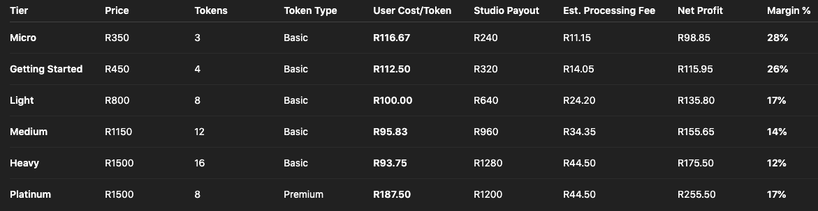
2. Studio Payout Structure & Participation Logic

### **Purpose:**

* Ensure studios are fairly compensated
* Create low-friction onboarding terms
* Encourage wide participation, especially in underutilized time slots

### **🧠 Rationale Behind Amounts**

* **R80 payout** makes Loop sustainable while offering a ~R100 user experience
* **R150 payout** incentivizes premium studios to participate despite higher margins  
  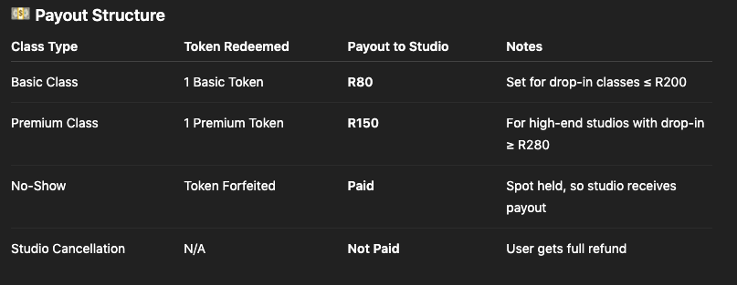
* Studios paid for **no-shows**, since a Loop user still reserved the slot

### **⚙️ Studio Participation Logic**

#### **1. Class Slot Controls**

* Studios can choose **how many Loop spots** are available per class (e.g., 2–4)
* This allows control over capacity and risk

#### **2. Class Eligibility**

* Studios may **select which classes** are Loop-eligible   
  + Off-peak slots? ✅
  + Lower fill-rate classes? ✅
  + Full peak slots? Optional ✅

#### **3. Late Cancellation Payout Toggle**

* Studios can **choose** whether to receive payout for late cancels  
  + Default = **No payout** (user gets token back)
  + Opt-in = **Yes payout** (user forfeits token if late)

#### **4. Studio Onboarding Requirements**

* Must have a **modern BMS** with calendar/class integration (via API or admin dashboard)
* Must agree to terms:  
  + Accept token-based users
  + Set cancellation window
  + Honor check-in QR or manual confirmation

### **💬 Suggested Studio Pitch Language**

*“We send you verified paying users to fill unused class capacity. You get paid automatically—no admin, no drop-in discounts, and you control how many Loop users you take.”*

1. Token Redemption Logic and Booking Rules (and strike system)

### **🎟️ Token Usage**

* Tokens are valid for 39 days
* Unused tokens expire after 39 days
* Users may hold up to 3 active bookings at any time
* Bookings may be made up to 7 days in advance
* Tokens are immediately redeemed upon booking

### **⏰ Booking & Cancellation**

* Cancellation window is defined by each studio (ranges between 4–12 hours)
* Cancelling inside the studio’s window = late cancellation
* Late cancellations = 1 strike

### **📱 Check-In Rules**

* QR check-in opens 30 minutes before class
* Check-in closes 5 minutes before class starts
* Check-in after this = late arrival
* 3 late arrivals = 1 strike
* No-show (no check-in + not marked attended) = 3 strikes

Strike and Restriction Policy

* At 3 total strikes, account is restricted for 14 days
* Users may attend any classes already booked
* Users can pay a fee to unlock their account early

1. Payments, Refunds & Top‑Ups Policy

### **Payment Processing**

* We use a South African payment gateway (e.g. PayFast, Peach Payments).
* **Processing fee is 2.9% + R1.00 per transaction**, covered by StudioLoop—no extra fees charged to users. (TBD)

### **Token Top‑Up Rules**

* Top-up: **minimum purchase of 2 tokens**, costing R150/token.
* Tokens expire **39 days** after purchase.
* Top-up tokens act as basic tokens and can be converted to premium (2:1 conversion).  
  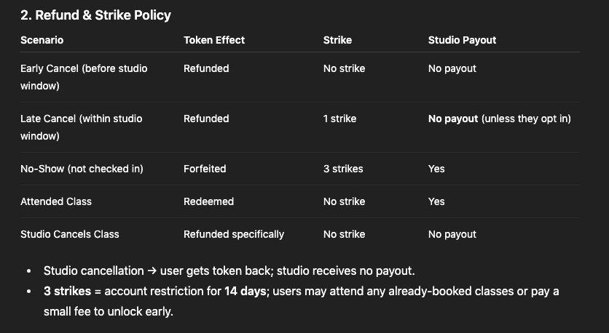
* **Top-up tokens are non-refundable.**

### **Studio Payout Rules**

* Studios receive payment only for:  
  + Attended classes (redeemed tokens).
  + Confirmed no-shows (since the spot was held).
* **Late cancels do not trigger payouts**, unless the studio opts into the **Late Cancel Payout** feature during onboarding. TBD
* Studio cancellations result in no payout, and **users are fully refunded** immediately.

### **✅ Why This Model Works for Everyone:**

* **Fairness for Users**: No double penalties, no surprises.
* **Fairness for Studios**: Paid reliably when attendance is confirmed.
* **Sustainability for StudioLoop**: Revenue and payout logic are aligned—no risk of funding cancellations.

1. Token Conversion Rules

### **Objective:**

To let users **access premium experiences** even without a premium subscription, in a way that’s flexible, fair, and financially sustainable for StudioLoop.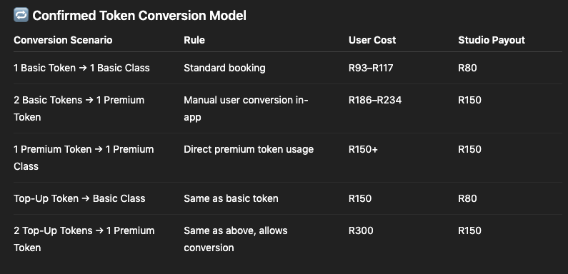

### **⚙️ Conversion Rules**

* ✅ Users can convert **2 basic/top-up tokens** into 1 premium token
* ✅ Premium tokens can only be used at **Premium Studios**
* ✅ Studio receives **R150 payout** per premium class, regardless of how token was acquired
* ✅ Maximum of **2 conversions per month** per user to prevent token stacking
* ✅ Conversion is user-initiated via app prompt (“Upgrade to premium class?”)

### **🔐 Studio Logic**

* Premium studios must either:  
  + Have a drop-in price ≥ R280
  + Or manually **opt into Premium Studio Tier** for visibility and R150 payout
* Studios do **not need to distinguish** between users who use a pure premium token vs. converted token

### **💬 Suggested In-App Language**

*“Want to try a Premium Studio? You can upgrade by converting 2 tokens. These are high-end classes with a regular drop-in of R280 or more!” (TBD)*

This communicates exclusivity, perceived value, and justifies the 2:1 ratio clearly.

### **⚖️ 3. Legal & Compliance**

* Draft Terms of Use & Privacy Policy
* Prepare studio partnership agreement
* Register StudioLoop
* Confirm payment provider agreements & compliance

### **📱 4. Product & UX Planning**

* Draft complete user journey (subscribe → book → attend → review)
* Wireframe all key screens
* Define MVP feature list
* Plan integration flow with studio systems
* Confirm QR check-in logic

### **🏋️ 5. Studio Readiness**

* Identify API-compatible launch studios
* Build studio value prop & pitch narrative
* Draft studio onboarding flow + partner FAQ
* Prepare mockups/demo tools for outreach
* Finalize first contact order and outreach script

### **📢 6. Marketing & Community**

* Buy domain + design logo
* Launch early access waitlist or landing page
* Design referral or incentive program
* Plan social and influencer launch calendar
* Collect pre-launch user feedback (survey or test group)

### **🧠 7. Team & Tech Setup**

* Finalize dev method (internal or agency)
* Lock in tech stack (e.g. Flutter, Firebase, Zapier)
* Assign team or partner roles
* Set up tools (Notion, Airtable, Slack)
* Define internal feedback + update loop